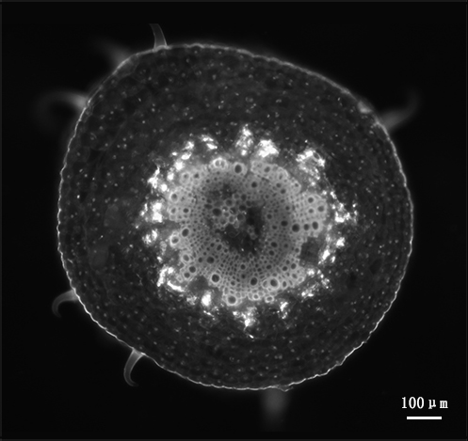
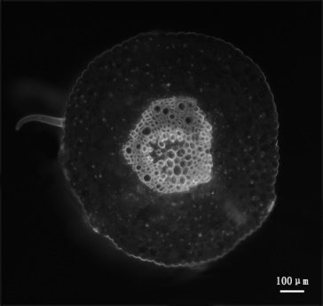
B
A

B
A

Additional file 5: Fig. S4: Determination of phytoplasma in the sieve element in jujube petiole phloem by using 4’,6-diamidino-2-phenylindole (DAPI). A, No fluorescent spots were observed in the sieve element (SE) of healthy plantlets. B, The fluorescent spots formed a large, bright circle in the sieve element (SE) of the diseased plantlets. The numbers and sizes of the fluorescent spots indicate the number of phytoplasmas. Bar = 100 µm.

